**Part-1**

Connect to FDU VPN

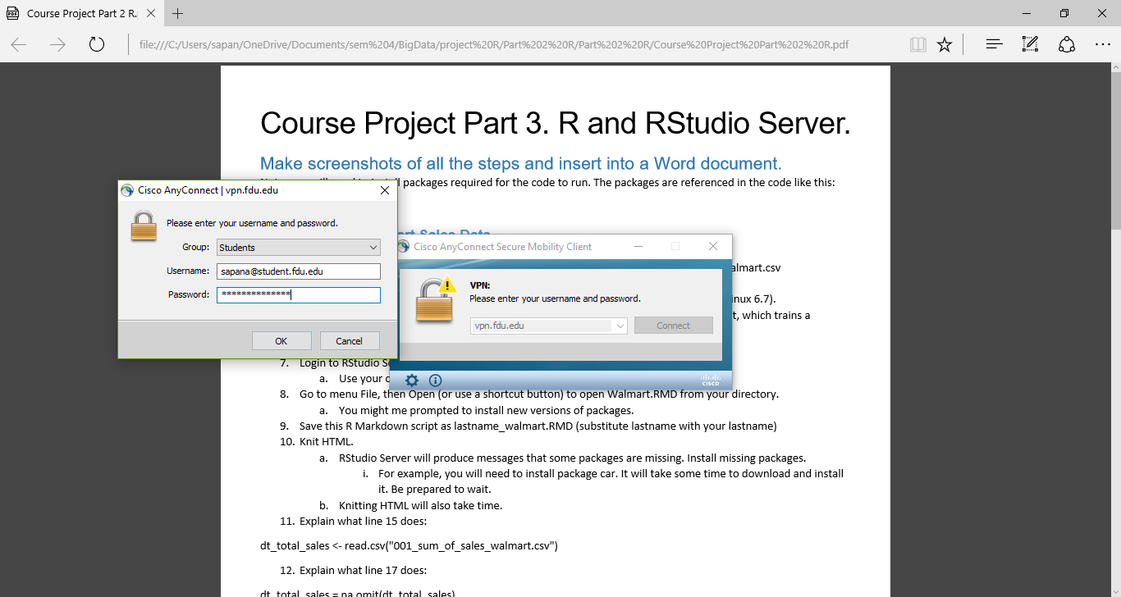

Download a dataset in CSV format from WebCampus. File name is 001_sum_of_sales_walmart.csv

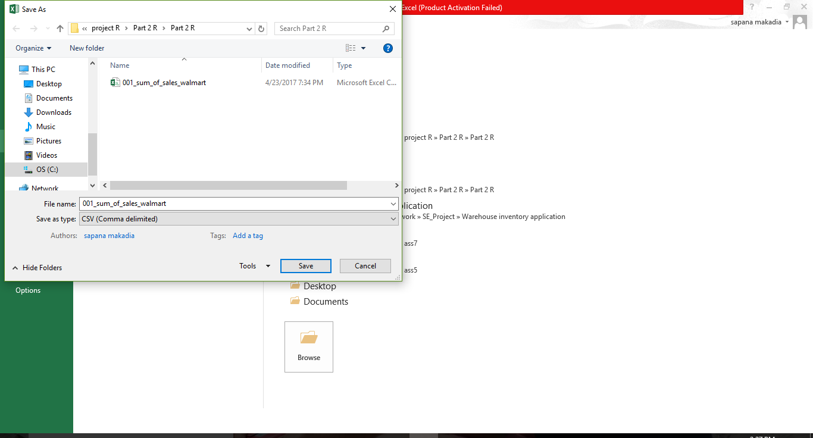

001_sum_of_sales_walmart.csv file

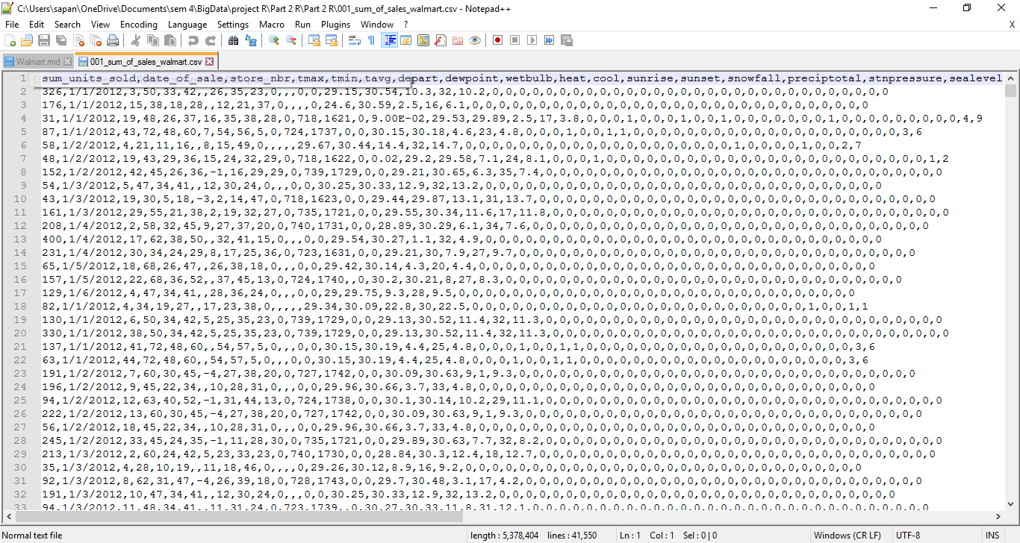

Transfer the downloaded CSV dataset to your home directory in Linux

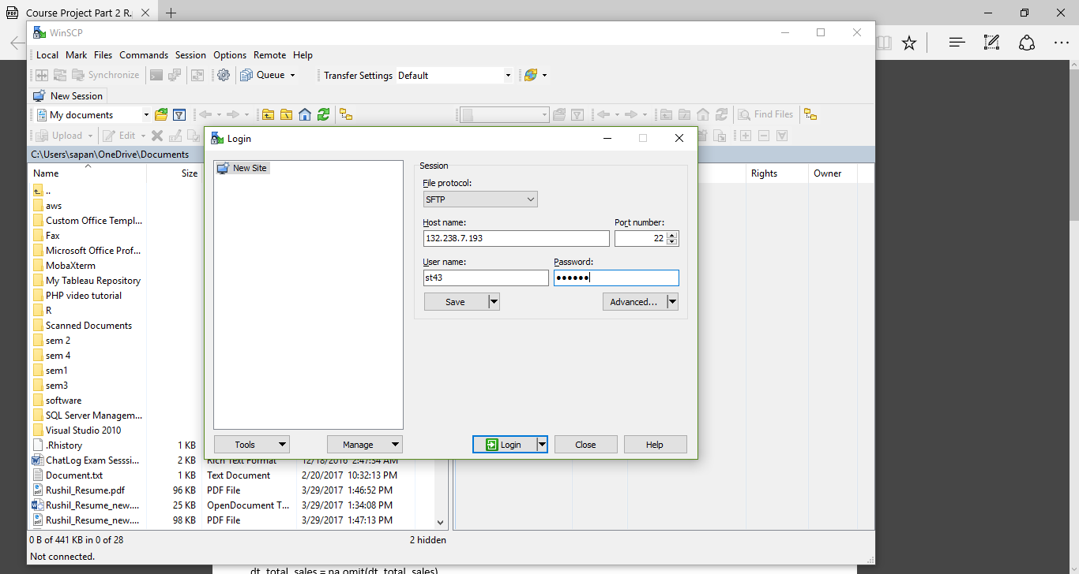

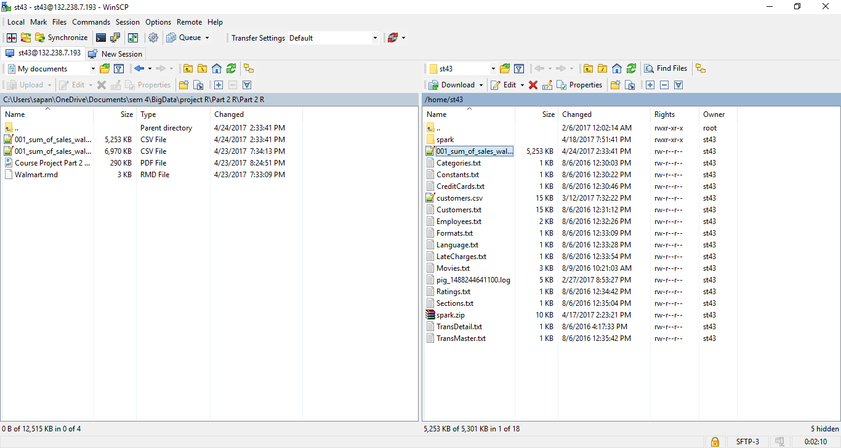

Transfer Walmart.RMD to your home directory in Linux

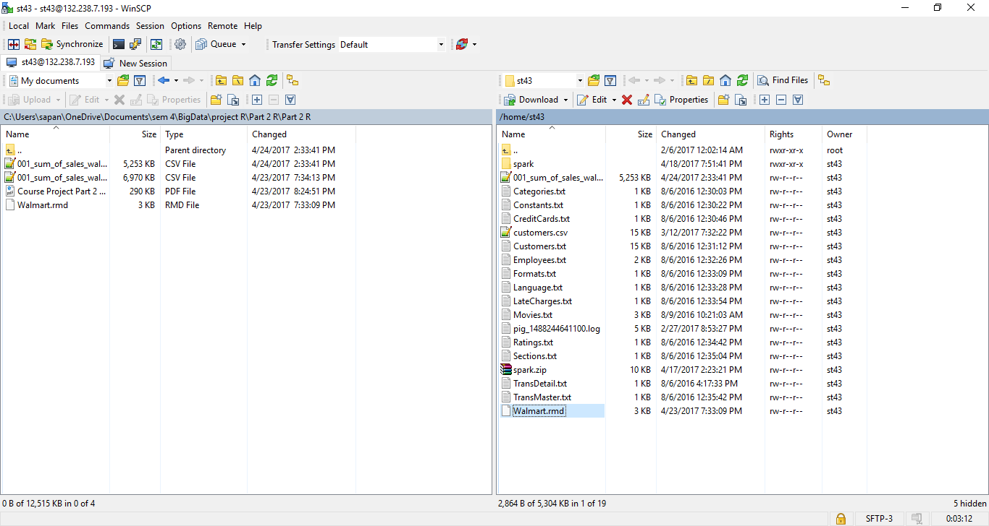

Login to RStudio Server by navigating to http://132.238.7.193:8787/

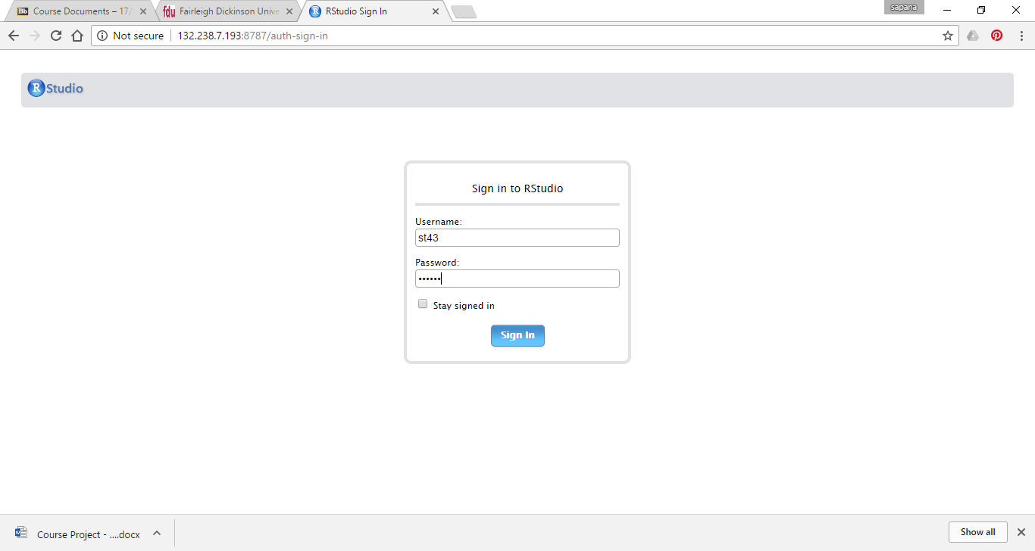

R studio

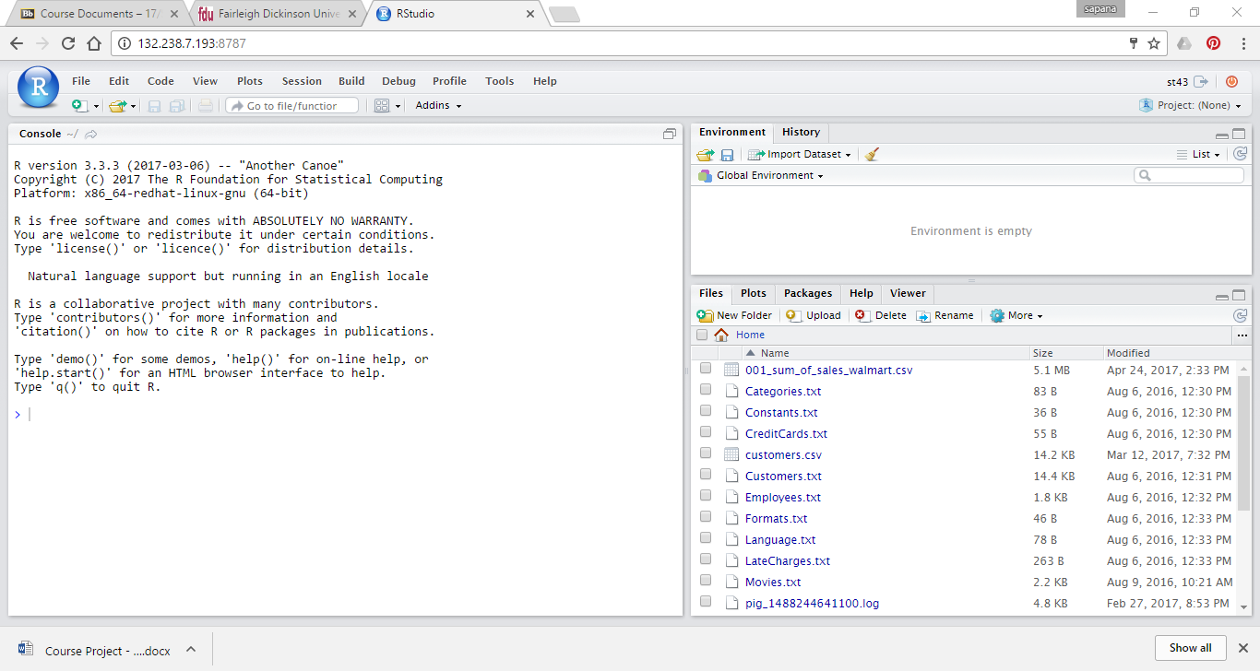

Go to menu File, then open Walmart.RMD from your directory

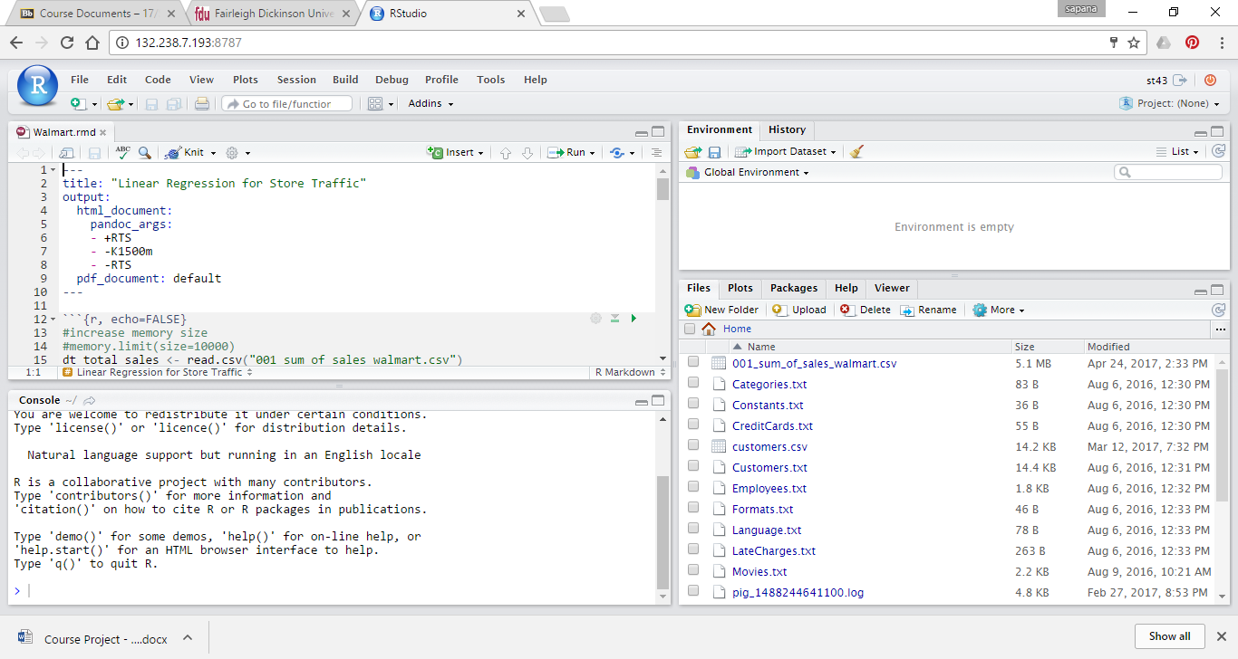

Save this R Markdown script as Makadia_walmart.RMD

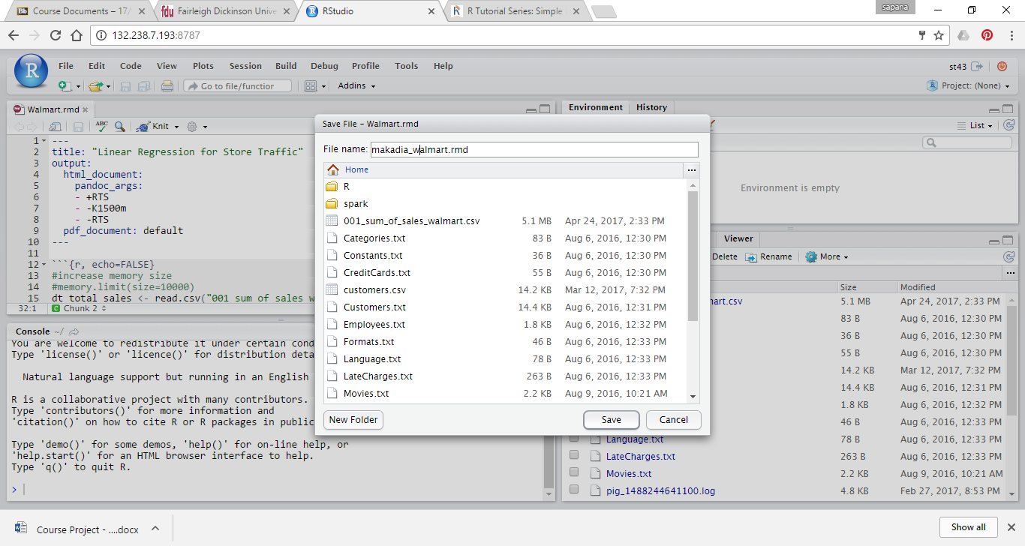

RStudio Server will produce messages that some packages are missing. Install missing packages

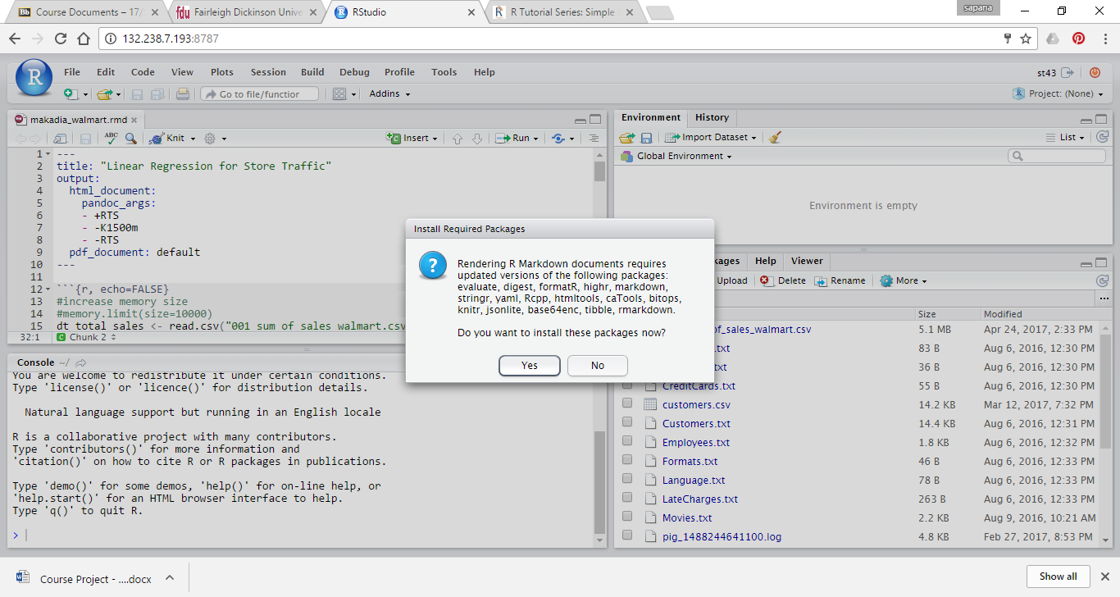

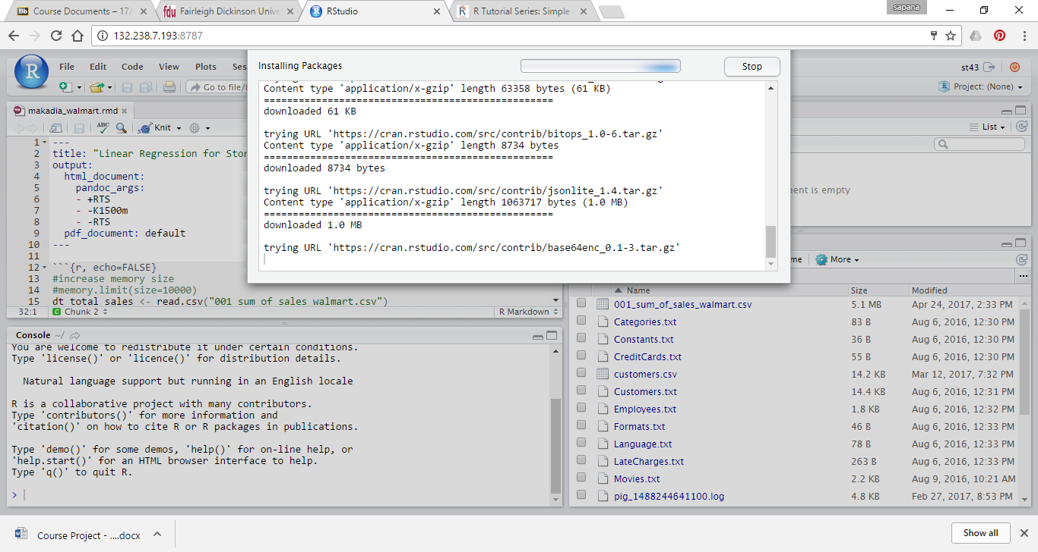

you will need to install package car otherwise it gives you error

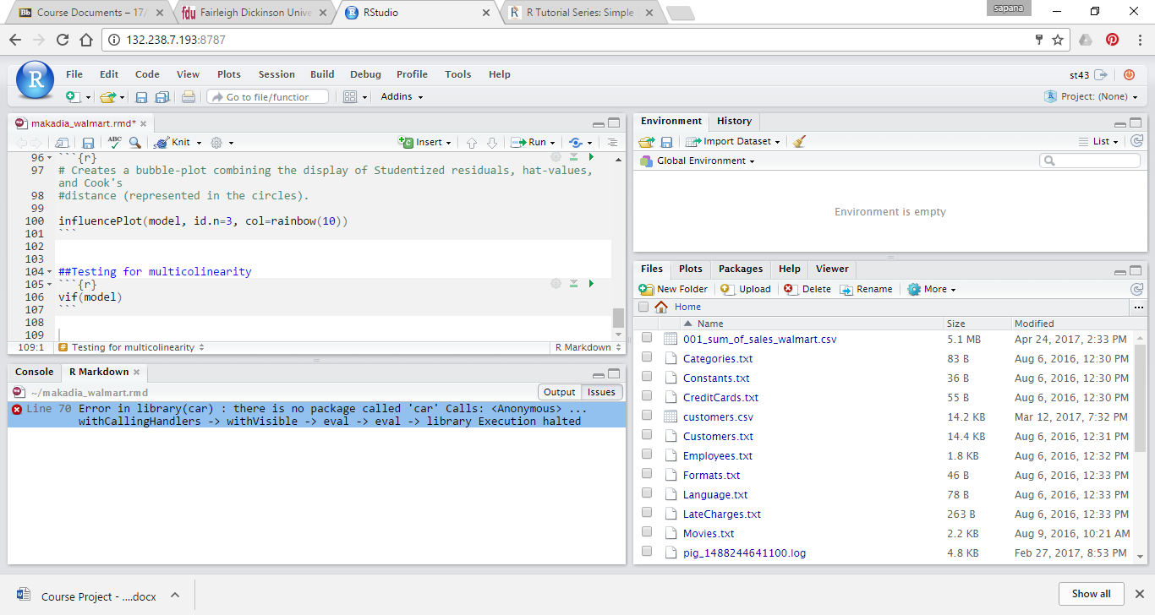

Installing “car” package

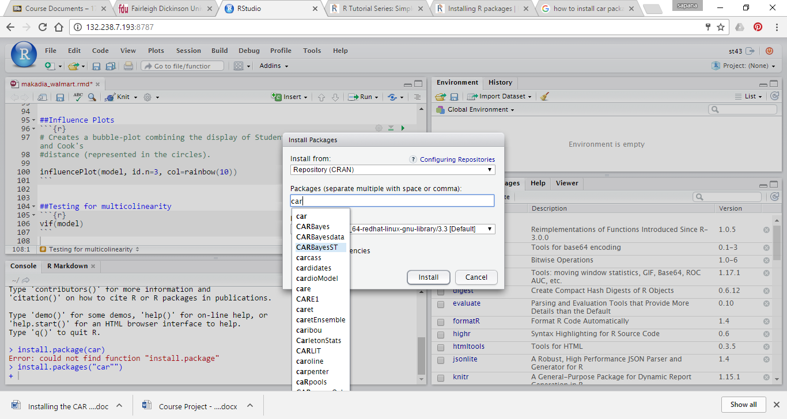

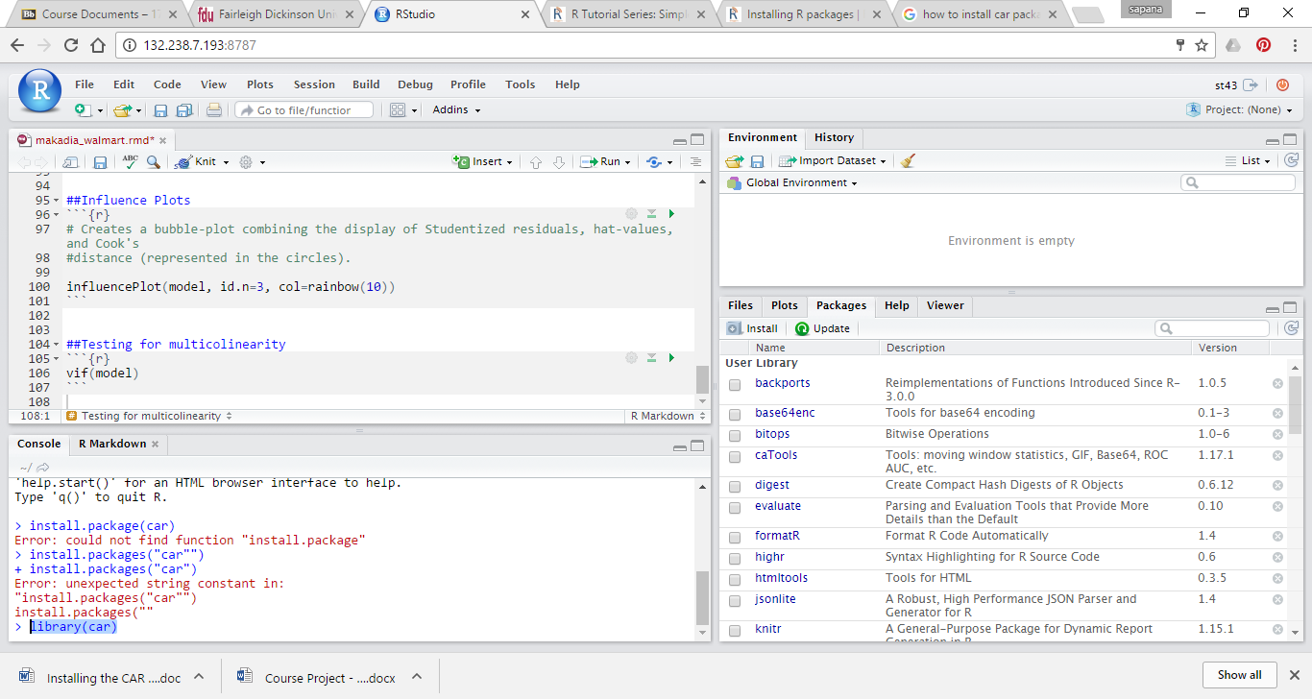

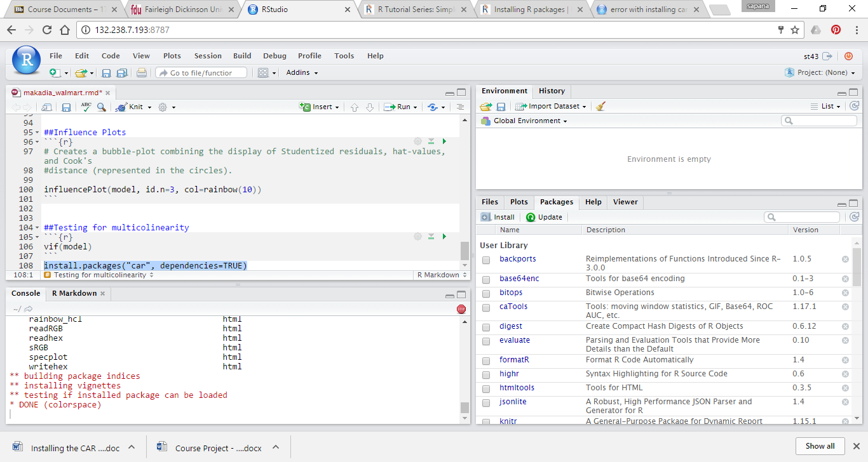

Knit HTML

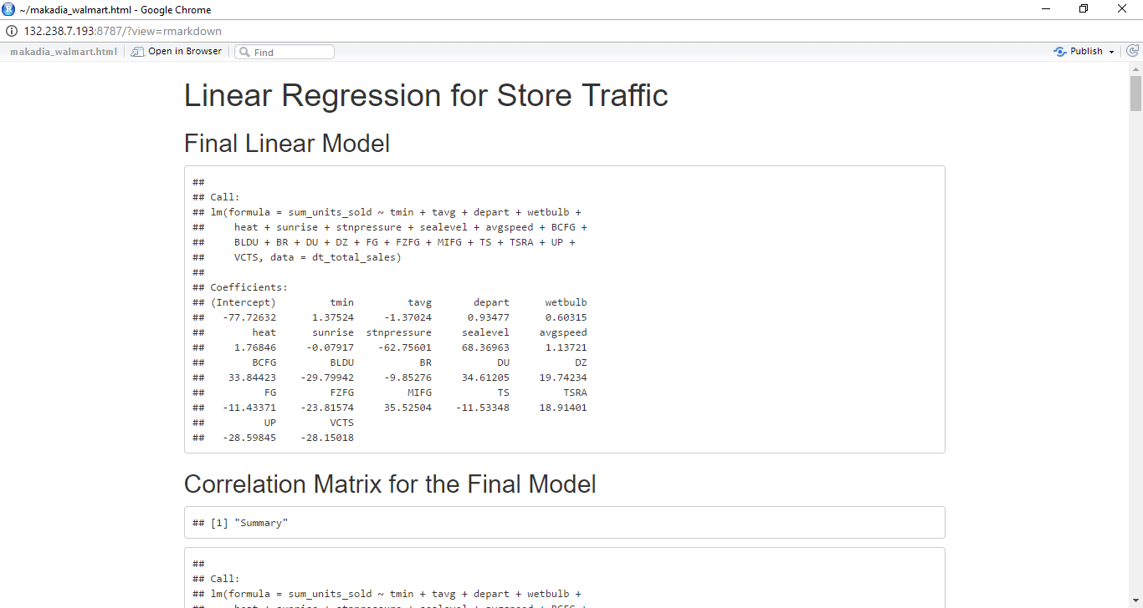

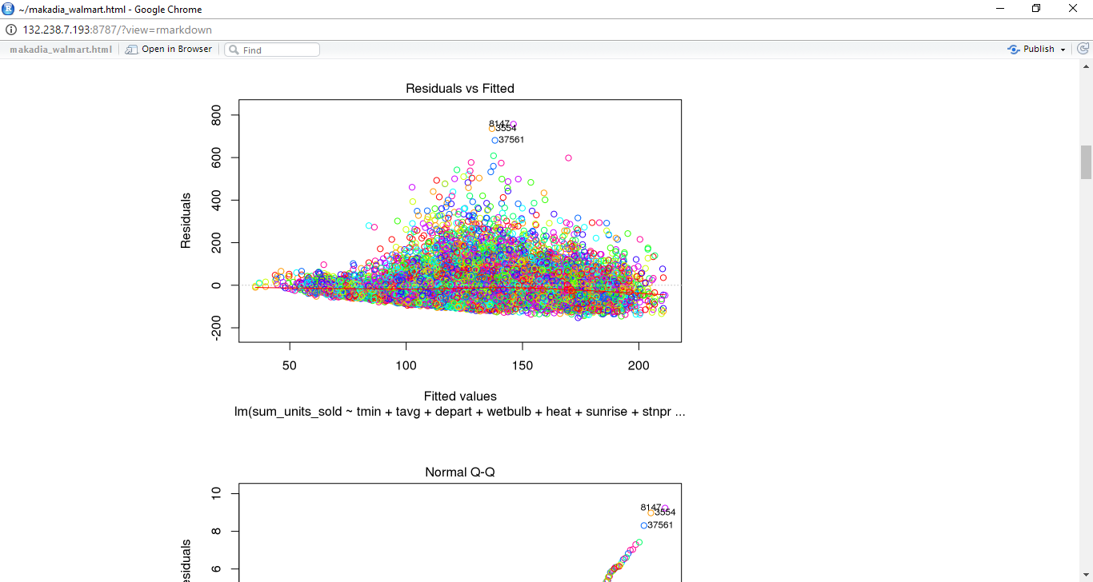

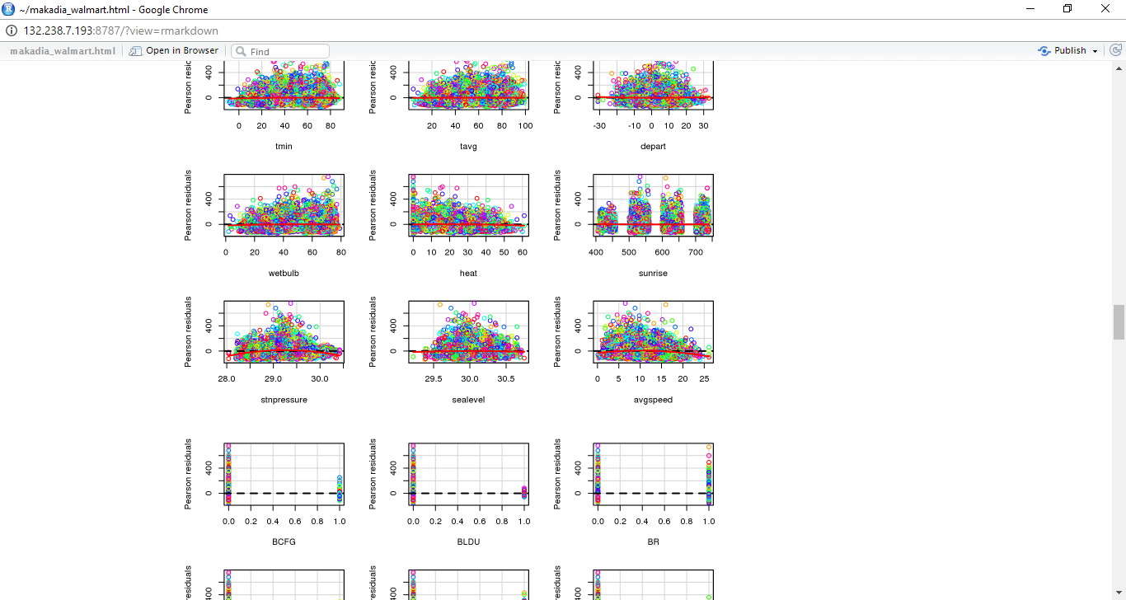

**Explain what this line does: dt_total_sales <- read.csv("001_sum_of_sales_walmart.csv")**

* It will read the csv file 001_sum_of_sales_walmart.csv and store data into data frame called dt_total_sales

**Explain what this line does: dt_total_sales = na.omit(dt_total_sales)**

* returns the object with observations removed if they contain any missing values

Change the code by simplifying the final model to predict sum_units_sold based only on the following variables: tmin, heat and avgspeed.

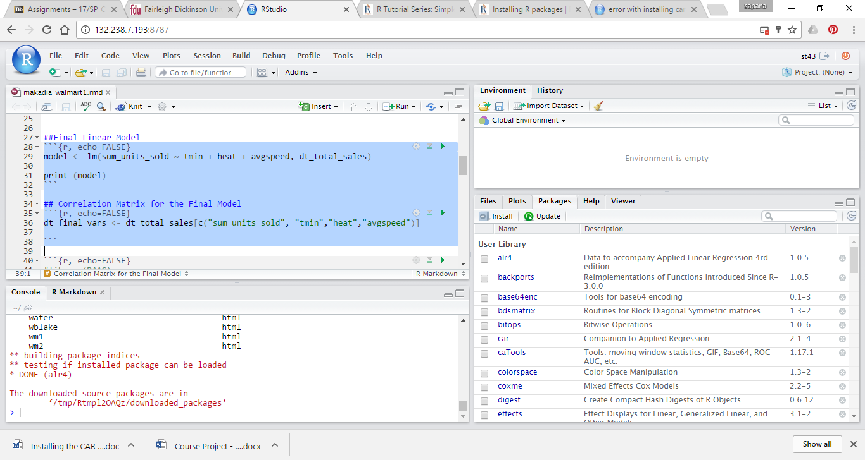

Knit HTML

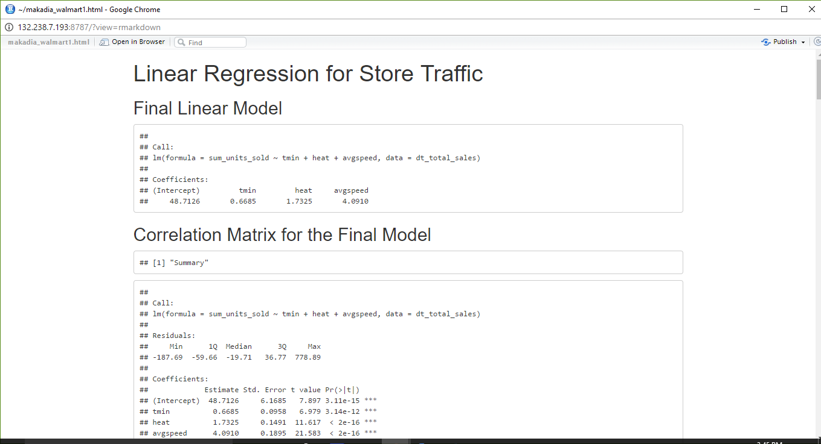

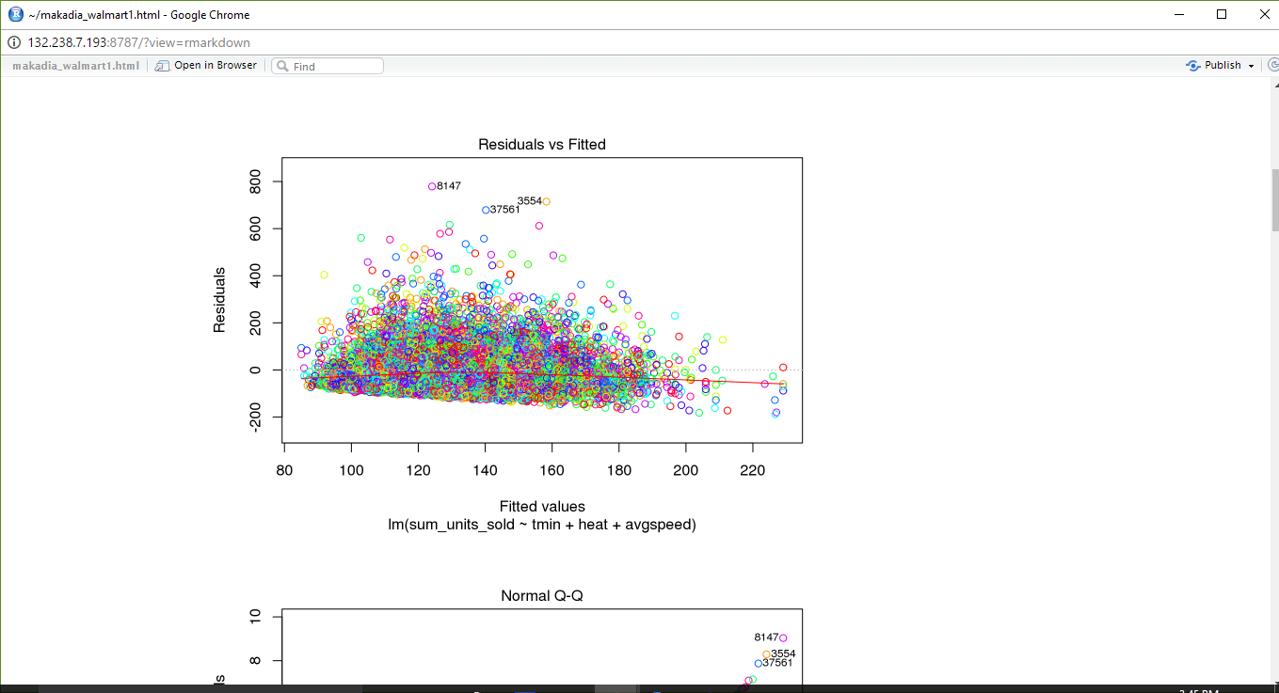

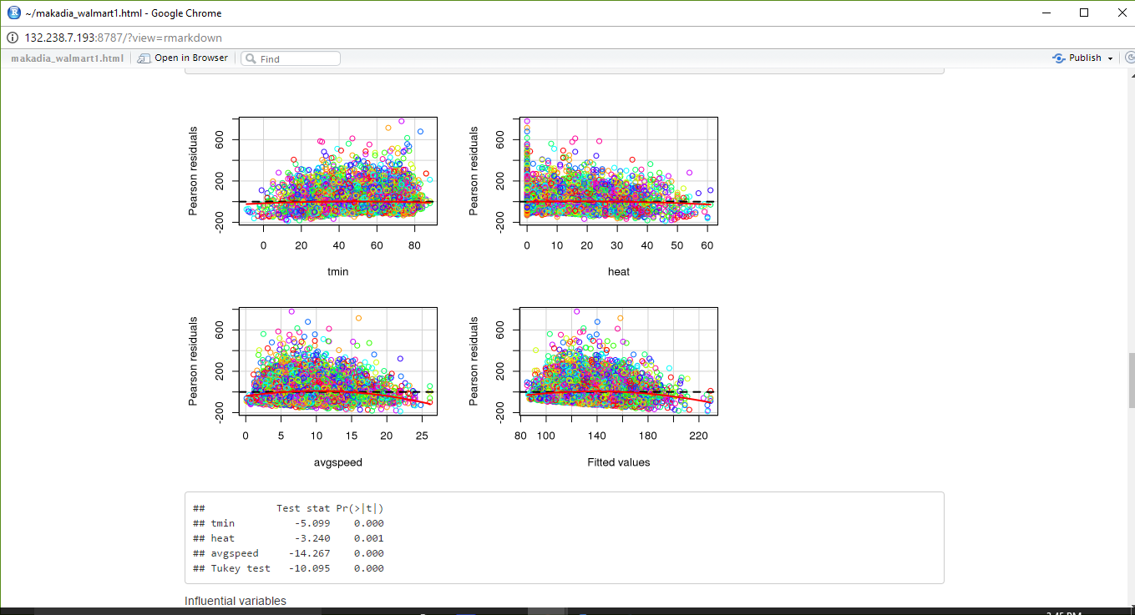

**Part-2**

You need to install RCurl package first.

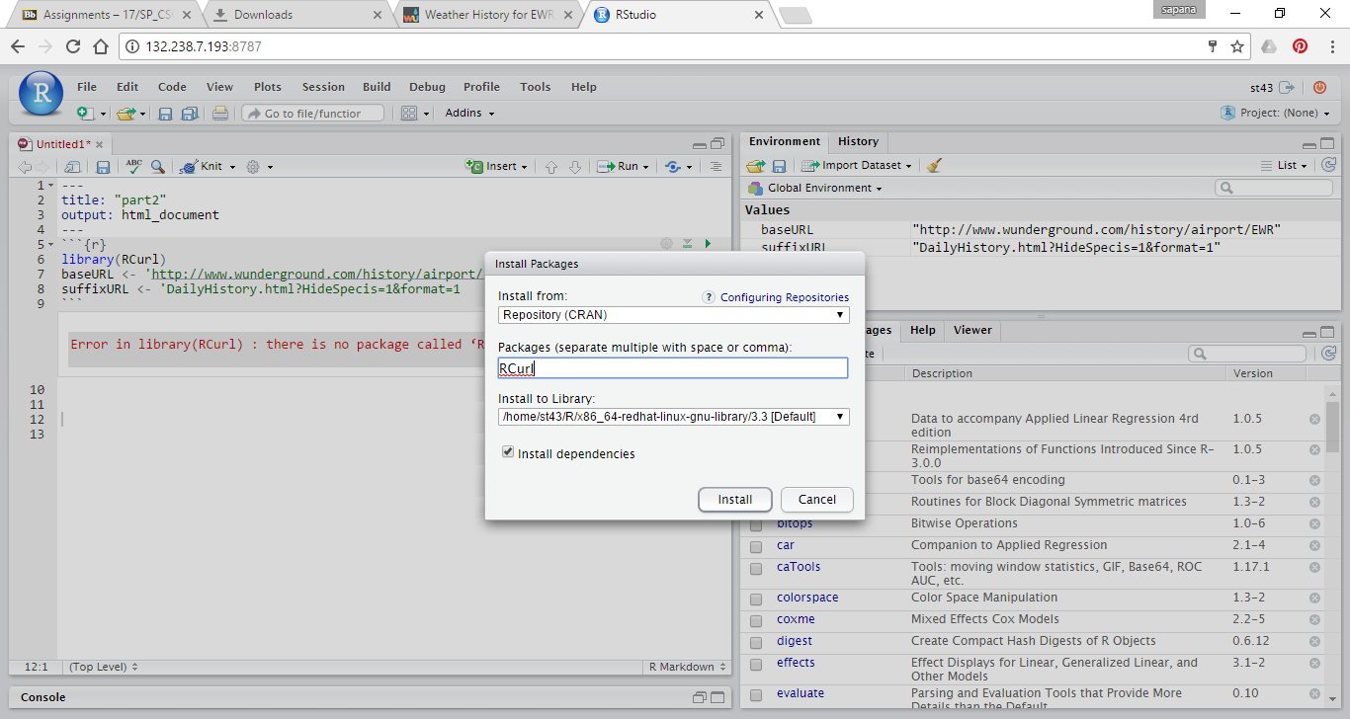

First, we define the beginning and end of the URL, which will never change for the Newark Airport

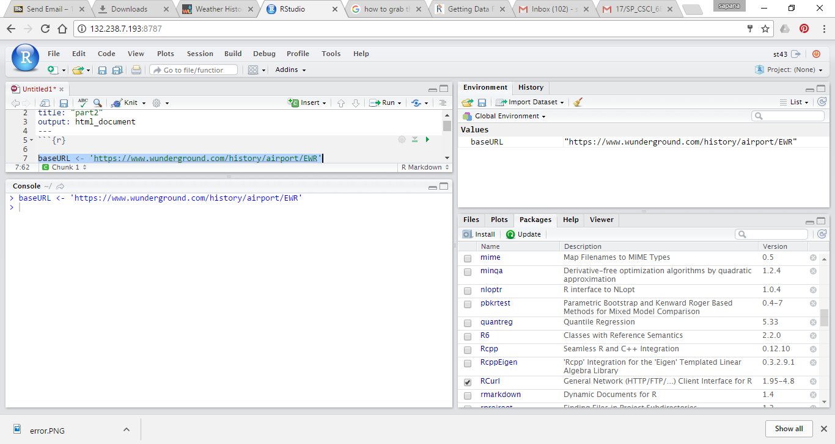

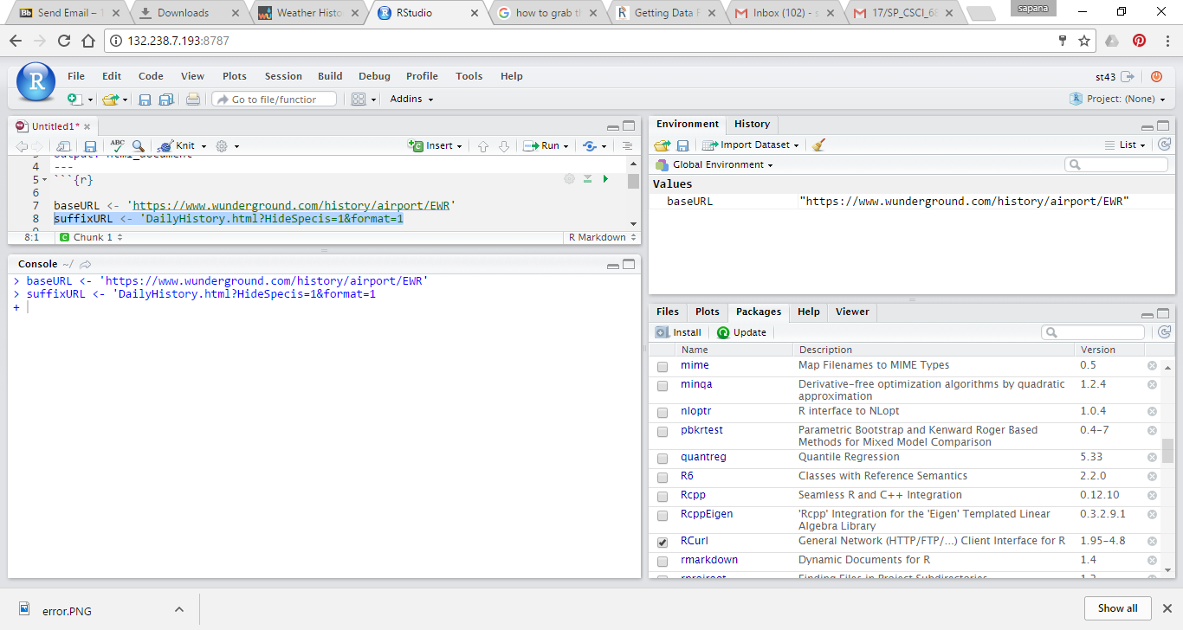

Then we get today’s date and from produce a string in format year/month/day

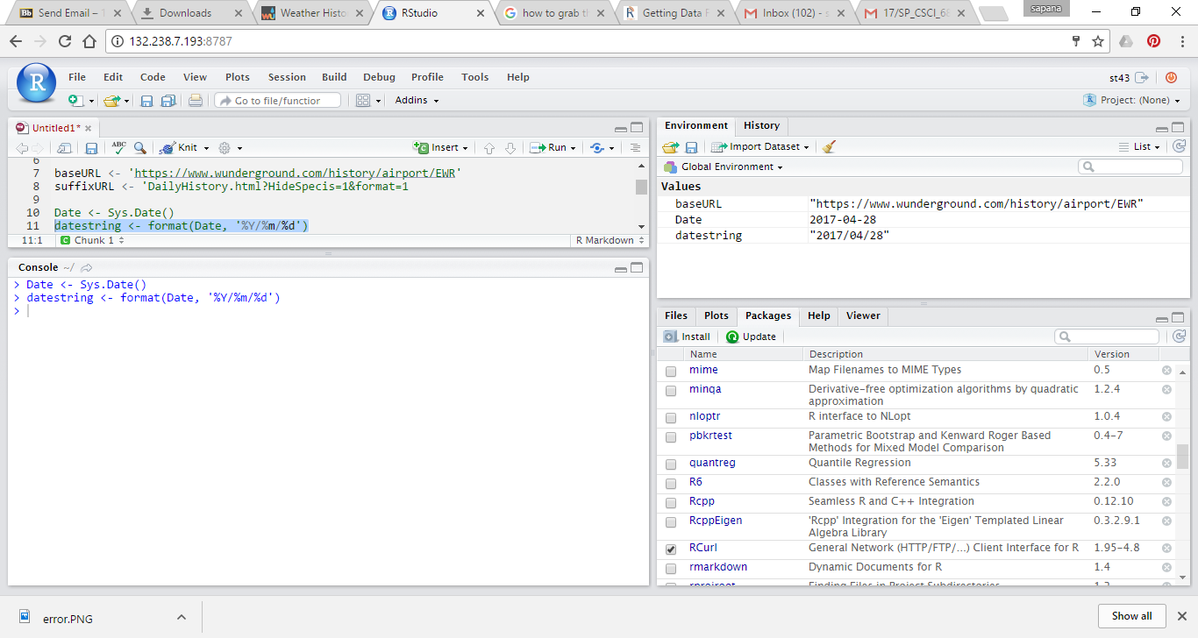

Combine all the parts of the URL and add the date to it.

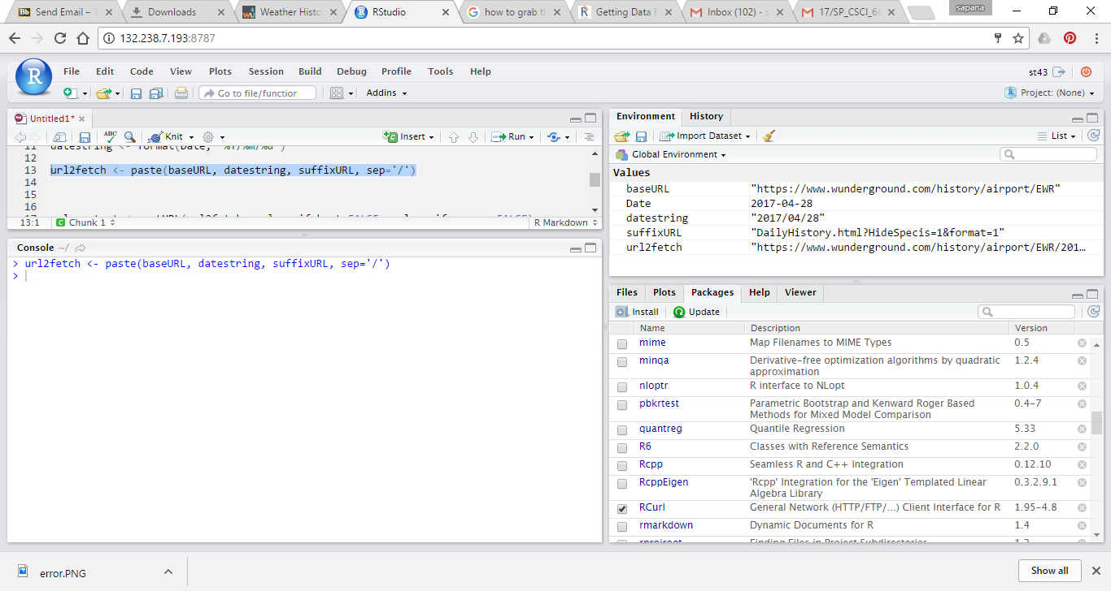

Grab the contents of the webpage at that URL using the RCurl method

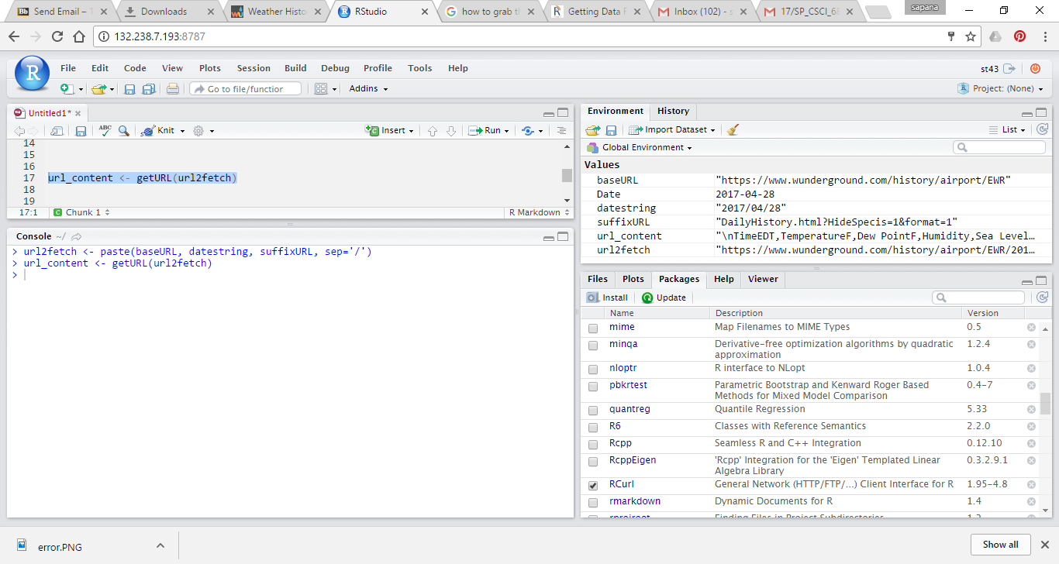

we have the content of the page in a string. We need to read the string into a data.frame object

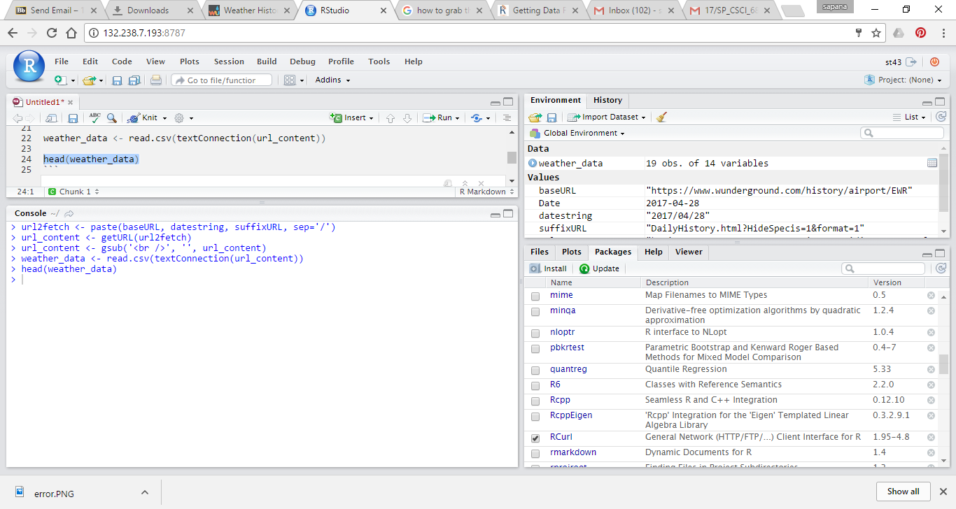

First 6 rows of data when you run head(weather_data) line

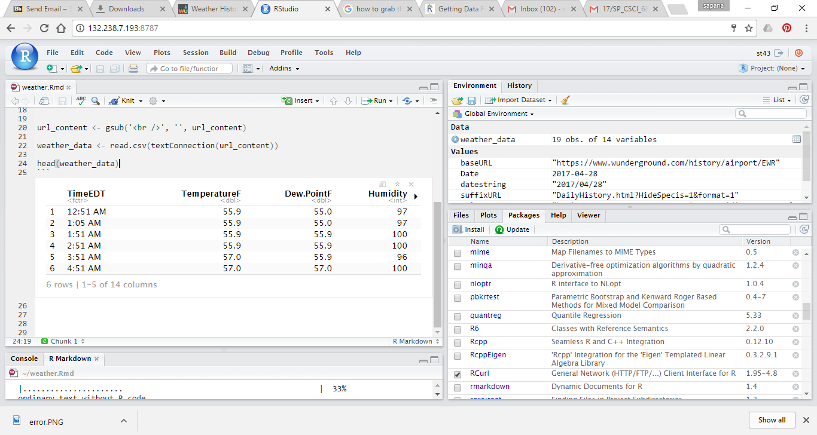

Output when you knit HTML

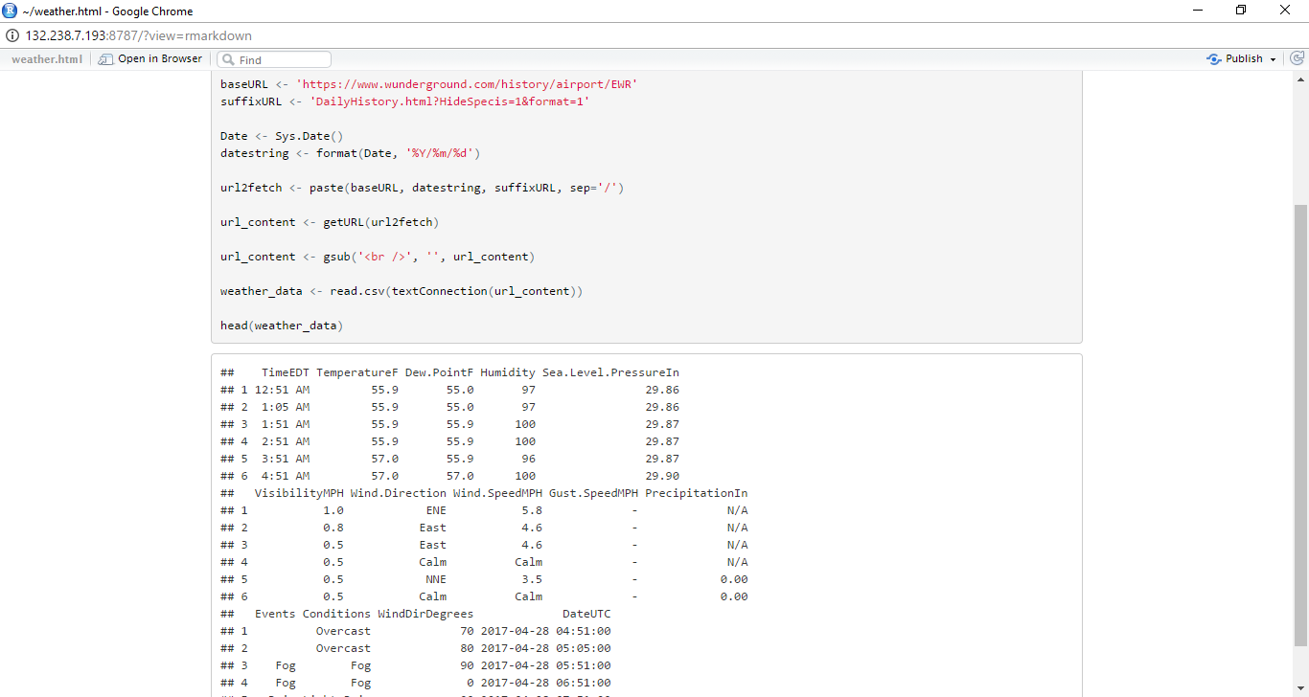

The describe function belongs to the Hmisc package. You need to install this package.

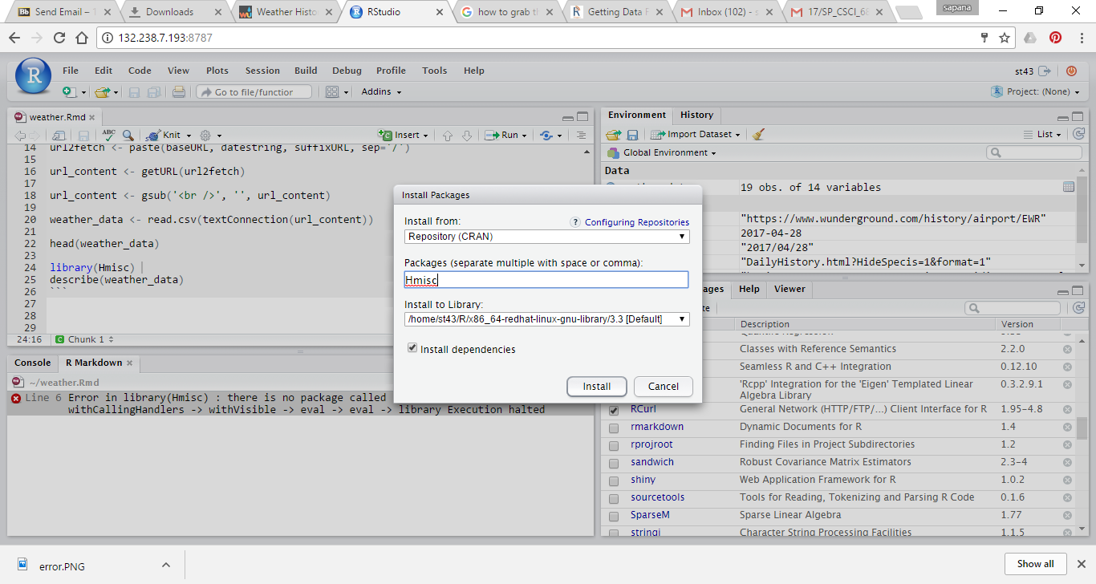

Let’s get extended descriptive statistics of the dataset by variable

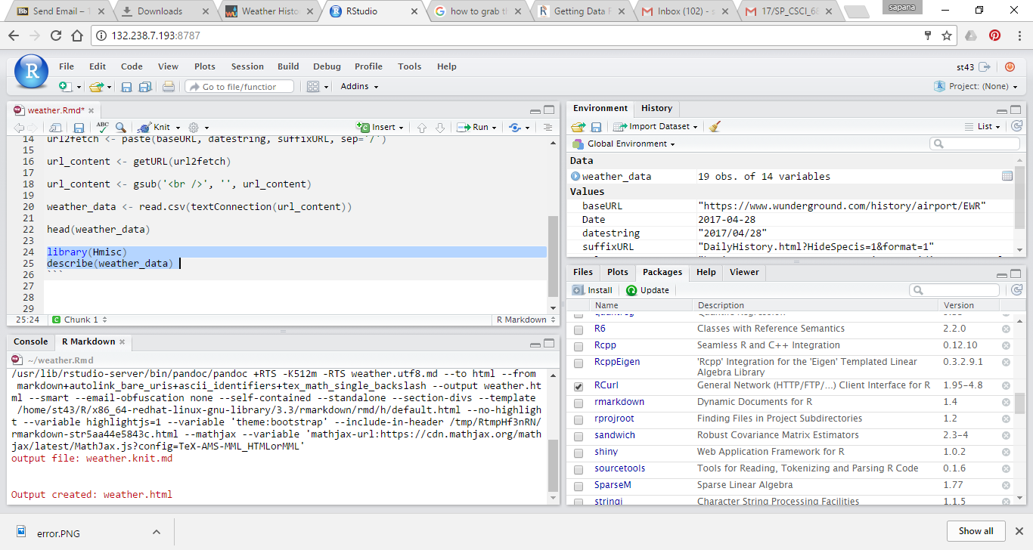

Knit HTML

